Name: SAYYAM SABOO

Roll No: PA-17

Batch: A-1

PRN: 1032211097

**FSD ASSIGNMENT 05**

**Theory**

1. What is React? Steps to run React app using create-react-app.

React is an open-source JavaScript library for building user interfaces, particularly for single-page applications (SPAs) and dynamic web applications. It is developed and maintained by Facebook and a community of individual developers and companies. React is known for its component-based architecture and its ability to efficiently update and render components as data changes. Here are the steps to run a React app using create-react-app, a popular tool for creating and managing React applications:

**Step 1: Install Node.js and npm**

Before you can use create-react-app and run a React application, you need to have Node.js and npm (Node Package Manager) installed on your computer. You can download them from the official website: [Node.js](https://nodejs.org/).

**Step 2: Install create-react-app Globally**

You can install create-react-app globally on your system using npm. Open your terminal or command prompt and run the following command:

bash

npm install -g create-react-app

This command installs create-react-app globally, allowing you to create new React applications using it.

**Step 3: Create a New React Application**

Once create-react-app is installed, you can create a new React application by running the following command:

bash

npx create-react-app my-react-app

Replace my-react-app with your preferred project name. This command will create a new directory with the specified name and set up a basic React application structure for you.

**Step 4: Navigate to Your Project Directory**

Change your working directory to the newly created React application directory:

bash

cd my-react-app

**Step 5: Start the Development Server**

To run your React application in development mode, use the following command:

bash

npm start

This command starts the development server, compiles your React code, and opens the application in your default web browser. You can access it at http://localhost:3000/. As you make changes to your React components, the application will automatically reload in the browser.

**Step 6: Edit Your React App**

Now, you can start editing your React app. The main entry point for your React application is the src/index.js file. You can create and modify React components in the src directory.

**Step 7: Build and Deploy Your App**

When you're ready to deploy your React app for production, you can build it using the following command:

bash

npm run build

This command generates an optimized production build of your React application in the build directory. You can then deploy the contents of the build directory to a web server or a hosting service of your choice.

That's it! You've successfully created a new React application using create-react-app and started a development server to run your app locally. You can now build and expand your React application according to your project requirements.

2. Passing data through props (Small example)

Passing data through props is a fundamental concept in React. It allows you to send data from a parent component to a child component. Here's a small example demonstrating how to pass data via props in a React application:

// App.js (Main Application File)

import React from 'react';

import Parent from './Parent';

function App() {

return (

<div>

<h1>App Component</h1>

<Parent />

</div>

);

}

export default App;

**FAQs**

What are React states and hooks?

**React States:**

A state is a built-in feature of React components that allows you to store and manage data that can change over time. States are essential for creating dynamic and interactive components. Each React component can have its own state, and when the state data changes, React will automatically re-render the component to reflect those changes in the user interface.

To use states in a class component, you typically define the state object in the constructor and access it using this.state’

**React Hooks:**

React introduced hooks in React 16.8 as a way to add state and other features to functional components. Before hooks, only class components could have state. With hooks, functional components can manage state and perform other side effects, making it easier to reuse logic across components and write more concise and readable code.

The useState hook, for example, allows you to add state to a functional component.

**Output: Screenshots of the output to be attached.**

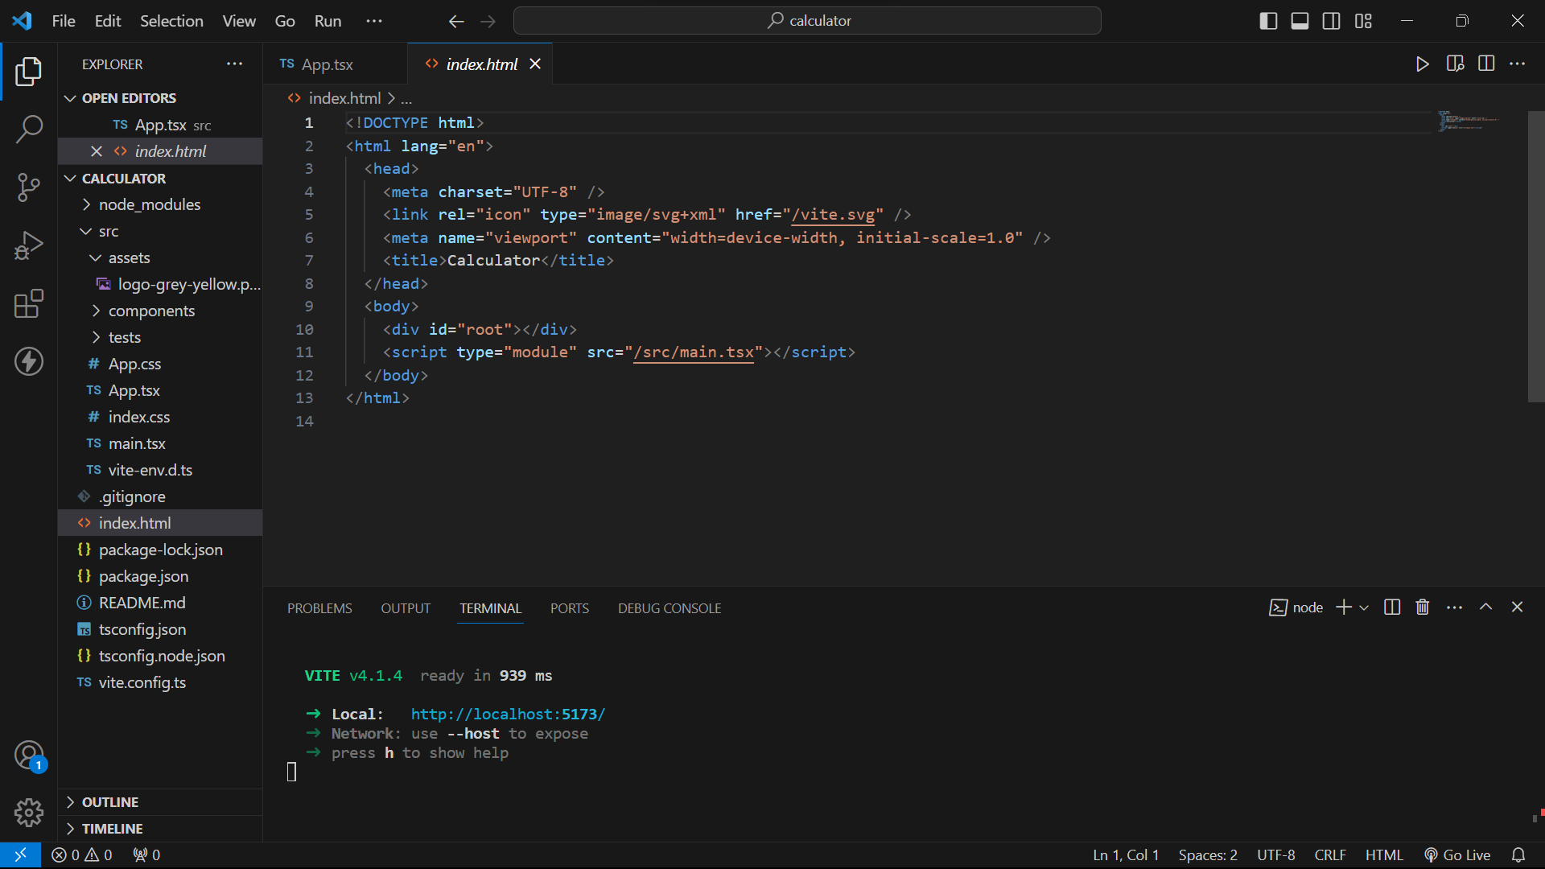

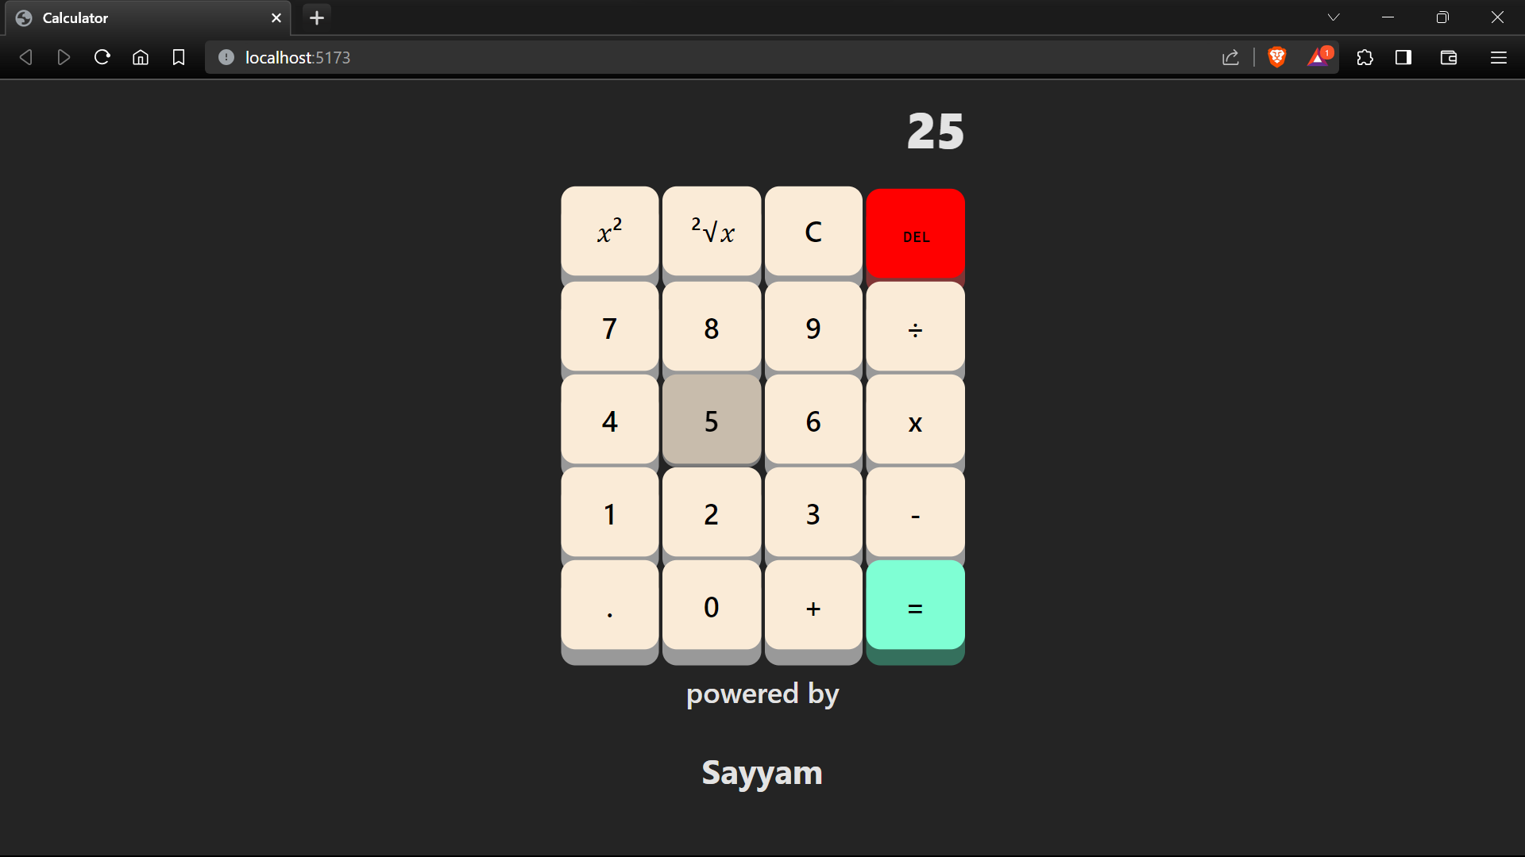

**FOR CODE-**

Github: <https://github.com/DarkShadows0401/FSD_LAB>